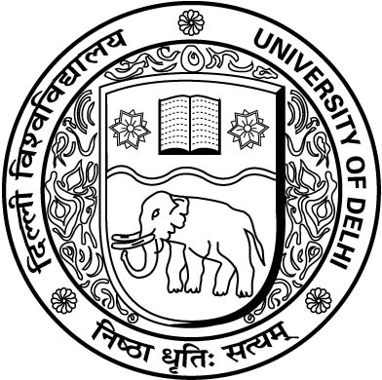
UNIVERSITY OF DELHI

Ref. No. /Dean(Exams.)/2020/ August 29, 2020

NOTIFICATION

Ref.: Submission of Examination form for the second phase of Open Book Examination (OBE) to be conducted in a blended (offline/physical and online) mode for the final semester/term/year students of UG/PG courses w.e.f. 14.09.2020 for the academic session 2019-20.

In compliance of the order passed by the Hon’ble High Court of Delhi on 17.08.2020 and 27.08.2020 in W.P. (C) No. 3199/2020, the second phase of Open Book Examination (OBE) for the students of the final semester/term/year in all Undergraduate and Post Graduate courses for the academic session 2019-20 shall be conducted in a blended (offline/physical and online) mode from 14.09.2020 onwards as per the office notification No./Dean (Exams.)/2020 issued by the Dean (Examination) on 28.08.2020.

The second phase of examinations will be conducted for those students of Undergraduate and Post Graduate courses (Regular and ex-students) including SOL and NCWEB who have either not appeared or have failed to upload/submit the scanned images of the answer scripts in the first phase of examination. Further, the students under the PWD category who have appeared in the first phase of examination but wish to improve their performance in selected paper/s can appear for the same in the second phase of examinations. The best grade/marks secured by the student based on the two examinations shall be taken into consideration for the preparation of results.

- The students who are appearing in the second phase of examination shall fill their examination form through the student portal of the examination branch. The link for accessing the portal is given below:

https://examportal.duresult.in/StudentPortal/login.aspx

- The Login details to access the portal will be (i) College Name, (ii) University Roll No. (iii) Student Name, (iv) Date of Birth and (v) E-mail.

- The student portal for filling the examination forms will be available online from 30.08.2020 onwards.

- The last date of submission of examination forms is 08.09.2020. No further date in this regard shall be extended.

Sd/-

Dean(Examinations)
University of Delhi, Main Campus, Delhi-110007 (India)
Tel:27001057/27667934, Website: du.ac.in

